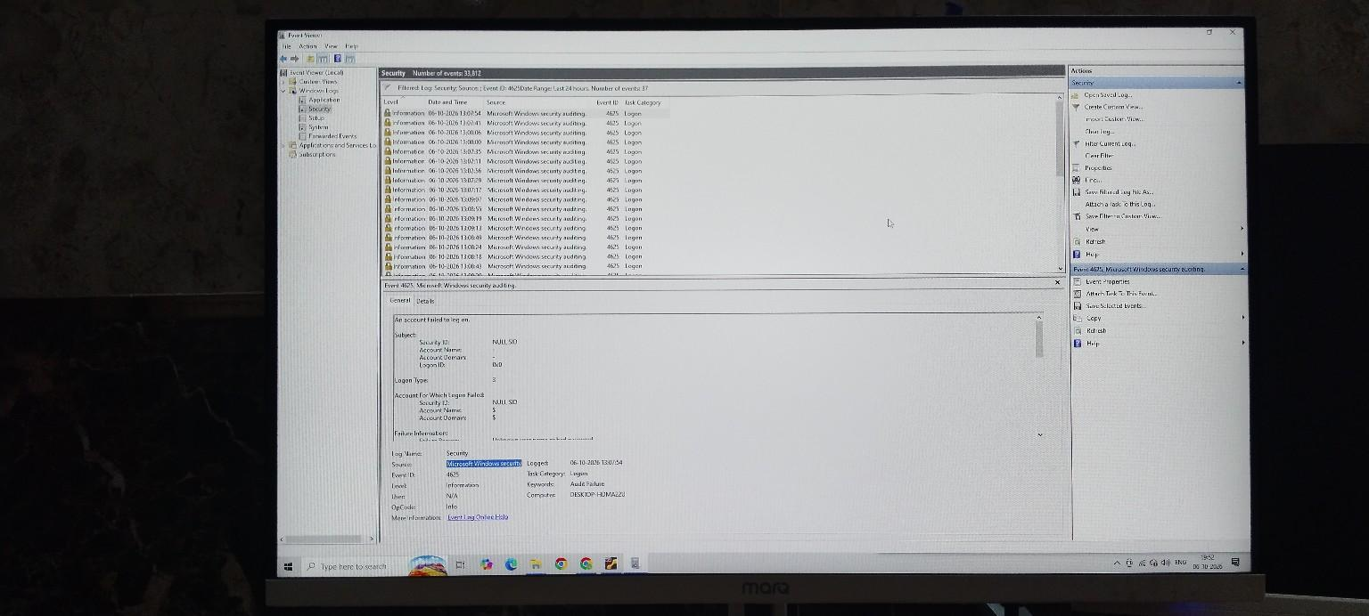

Figure 2 — Event ID 4625: Failed Logon
I investigated Event ID 4625 to identify a failed authentication attempt. From a SOC perspective, repeated failed logons can be important because they may indicate brute-force or unauthorized access attempts, so the account and logon type should be reviewed.

